Action plan
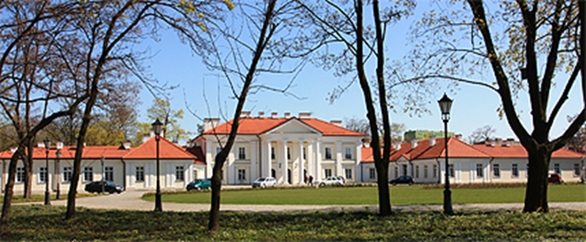
Case number: 2019PL469962
Name Organisation under review: Siedlce University of Natural Sciences and Humanities
Organisation’s contact details: Konarskiego 2, Siedlce, 08-110
University of Natural Sciences and Humanities is located in Siedlce – town in a distance of 90 km to east from Warsaw. We are a multi-profile institution of higher education with over 50-year long tradition in the field of education and research which integrates both natural, humanities, medical and social sciences. We have 5 faculties: Faculty of Social Sciences, Faculty of Humanities, Faculty of Exact and Natural Sciences, Faculty of Agriculture and Animal Husbandry and Faculty of Medical and Health Sciences. The research personnel carry on many scientific collaborations, co-operate with different scientific journals and also contribute in Polish and European projects.
The strategy for managing research staff of the University of Natural Sciences and Humanities in Siedlce (hereinafter referred as UPH) is based on the Researcher's Charter and the Code of Conduct for the Recruitment of Researchers. The strategy assumes building

a team of scientists with high research skills, as well as the implementation and application of research and development policy.
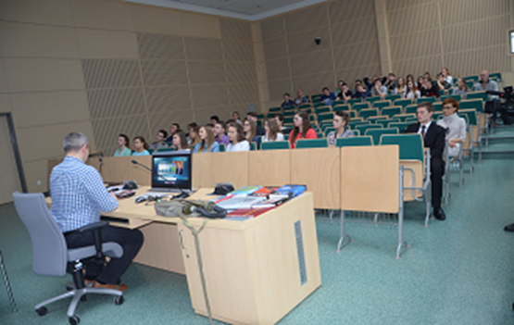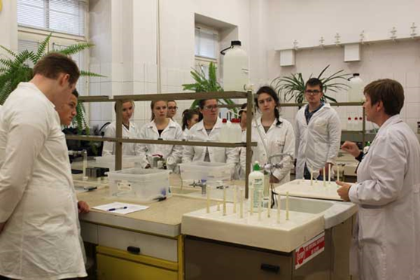
The process of creating the strategy and implementing the provisions of the Charter and the Code began in 2016. At that time, an Implementation Team was appointed whose task was to:
- Planning, developing and evaluating the compliance of internal procedures with the principles of the Charter and the Code
- Elaboration of an evaluation questionnaire and analysis of the results in order to identify the actual state.
- Develop an action plan in areas where discrepancies are visible.
- Monitoring the course of actions aimed at adjusting to the Charter and the Code.
The Implementation Team was composed of representatives of the management staff of the University at the rector and faculty level as well as representatives of the central administration.
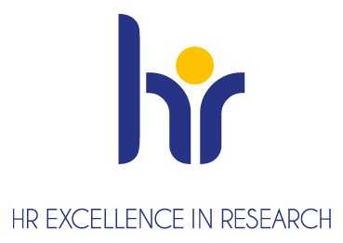
The action plan, developed on the basis of the evaluation questionnaire, was presented to the European Commission, which on this basis distinguished UPH by awarding the University with the HR Excellence in Research (November 22, 2017).
The implementation of the HRS4R Strategy and the OTM-R policy at UPH is one of the priority activities in UPH's pursuit of scientific excellence: creating a friendly research environment, improving the quality of this work and research, as well as ensuring transparent rules for recruiting employees. An important element of the implementation of the principles of the European Charter for Researchers and the Code of Conduct for the Recruitment of Researchers at UPH is the monitoring of the effects and progress in implementing corrective and self-improvement measures specified in the Strategy.
For this purpose, the Steering Committee has been appointed, whose main tasks are:
- Initiating activities in accordance with the adopted action plan included in the HRS4R strategy
- Monitoring the implementation of activities in accordance with the schedule adopted in the HRS4R strategy
- Providing the Rector of UPH with comments on the implementation of the strategy
- Preparation of questionnaires and conducting surveys among UPH employees
- Elaboration of analyzes for internal and external audits related to implementation of the HRS4R strategy at the University.
The work of the Committee is managed by Vice-Rector for Research and International Cooperation, who is responsible for:
- supervision over the ongoing work of the Team
- coordination of works carried out by the Team in accordance with the adopted schedule
- submitting periodic reports on the activities of the Team to the Rector of UPH.

Strengths and weaknesses of the current practice
THE SURVEY POLL RESULTS OF SIEDLCE UNIVERSITY OF NATURAL SCIENCES AND HUMANITIES (2021)
Graph illustrating the SURVEY results
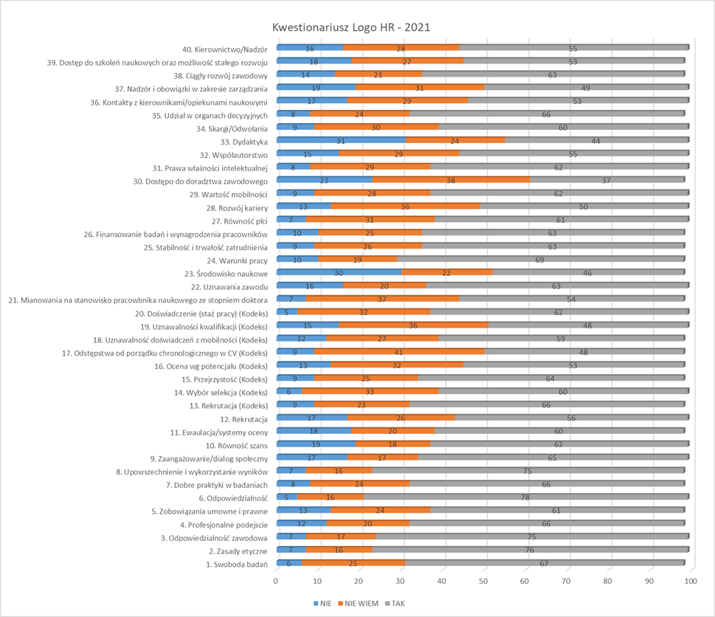
- Ethical and potential aspects
The first section of the questionnaire consisted of 11 (from 1 to 11) questions regarding ethics.

Based on the survey responses, it can be concluded that our University’s strengths lie in the areas as follows:
6. Accountability/Responsibility – 78% of the respondents reported a responsibility to the University or other institutions which provide funding for research, and to the whole community. 16% found it difficult to express their view on that issue, while 5% responded negatively.
It is an increase of 4% in comparison to the answers provided in the questionnaire in 2016.
3. Professional responsibility – 75% of the respondents reported a responsible approach towards research and that their research had been valuable for the public. Our researchers avoid plagiarism, obey intellectual property rights and co-authorship rules in research.
2. Ethical principles – 76% of the respondents confirmed that they were familiar with the ethical principles or standards outlined in different codes of ethics connected with the area of responsibility at the national, sectoral and institutional levels. 16% of the researchers found it difficult to express their opinion about that issue, and 7% gave a negative response to that question.
The researchers are aware that it is illegal to falsify research results to mislead the public. Legal provisions in this area are followed. They are also aware of the fact that maintaining standards needs to increased credibility of the University and the domestic and foreign research staff.
8. Dissemination, exploitation of results - 75% of the respondents gave a positive response to that issue confirming their awareness of their responsibilities in the area of publication, dissemination, and commercialization of research results. 16% of the respondents found it difficult to answer the question relating to that issue, while 7% provided a negative answer.
The new system of research evaluation implemented in 2019 favours the popularization of research results. It rewards the dissemination of research results in index- linked scientific journals in international data bases.
Weaknesses:
5. Contractual and legal obligations - 61% of the researchers provided a positive response, 24% of respondents found it difficult to answer the question on that problem, and 13% responded negatively. However, an increase of 9% was reported in comparison to the questionnaire carried out in 2016.
11. Evaluation/appraisal systems - 60% of the researchers provided a positive response. 20% of the answerers reported to be unable to refer to the issue, and 18% provided a negative response- a decrease of 7% compared to 2016. This might be connected with frequent changes in legal regulations and the COVID-19 pandemic (the research staff appraisal has been postponed). A new system of the evaluation of scientific activities has been implemented Since 2019, which has an impact on the criteria of periodical evaluation.
- Recruitment and selection
Questions from 12 to 21:
Strengths:
13. Recruitment (Code) - 66% of the answerers provided a positive response, while 23% were unable to give an opinion on that issue. Finally, 9% of the research staff provided a negative response. The results are similar to the ones received in the questionnaire in 2016. They confirmed that the researchers are familiar with the recruitment rules based on Act of 20 July 2018, The Law on Higher Education and Science and the Statute of UPH. New internal regulations are being planned that will outline recruitment rules for researchers.
15. Transparency (Code) - 64% of the respondents provided a positive response, and 25% found it difficult to express their opinion on that, 9% communicated a negative opinion on that. The researchers are aware of the recruitment process, selection criteria. They are informed about the number of available positions.
A high level of satisfaction with that issue results from the fact that UPH has clear recruitment procedures. Job openings are posted on the University website and on the website of the Ministry of Science and Higher Education, with the detailed description of the requirements and recruitment procedure.
20. Seniority (Code) - 62% of the researchers expressed a positive opinion on that, 32% reported to be unable to answer the question, and 5% provided a negative response. The results confirmed that the level of required qualifications is adequate to the position offered and does not constitute a difficulty in applying. The entire career development path is taken into account when assessing a candidate.
Weaknesses:
17. Variation in the chronological order of CVs (Code) - 48% of the researchers indicated satisfaction with the issue, 41% showed that were unsure about it issue, 9% demonstrated a negative attitude. Surprisingly, a lot of people have no opinion about the issue. Perhaps, this question should be more precise in the questionnaire in the future.
19. Recognition of qualifications (Code) - 48% of the answerers provided a positive response, 36% found it difficult to answer the question, 5% expressed a negative opinion on that. Interestingly, a lot of people were unable to provide a response to this question, so perhaps it wasn’t precise enough.
- Working conditions
Strengths:
24. Working conditions - 69% of the researchers satisfied with working conditions, 19% reported to be unable to refer to it, and 10% provided a negative response. The results are quite similar to the ones achieved in 2016. They confirmed that our University provides our researchers with good and flexible working conditions, including disabled people. The flexible working hours allow our researchers to achieve a healthy work -life balance. The researchers can apply for sabbatical leave and a research position without the necessity to conduct teaching.
35. Participation in decision-making bodies - 66% of the researchers were happy with their participation in the decision-making bodies, 24% reported to be unable to refer to this question, 8% provided a negative response.
The researchers confirmed their participation in the main University bodies such as the Senate and different committees, etc. These bodies have an influence on the implementation of the main activities of the University and participate in decision-making process.
Weaknesses:
30. Access to career advice - 37% of the researchers demonstrated satisfaction with their Access to career advice, 38% indicated to be unable to respond to the question, 23% provided a negative response.
The issue was referred to in Action Plan (Action no 5) in 2016.
33. Teaching - 44% of the researchers were satisfied with the issue, 24% reported to be unable to refer to this question, while 31% provided a negative response.
Teaching constitute a vital part of the researchers’ work. However, the new Statute makes it possible for them to occupy a research position without the need to conduct teaching, which allows them to concentrate just on research.
- Training and development
Strenghts:
38. Continuing Professional Development - 63% of the researchers indicated their satisfaction with the issue, 21% reported to be unable to refer to that issue, 14% communicated a negative response.
There has been a 16% rise in satisfaction with professional development compared to the questionnaire in 2016.
39. Access to research training and continuous development - 53% were happy with their Access to research training and continuous development , 27% communicated not being able to refer to it, 18% gave a negative answer. There has been a 7% jump compared to 2016.
The University supports its research in their professional development by allowing them to participate in research teams and research projects. Moreover, it funds training and research internships. The researchers are updated on training session, conferences, webinars, and projects offered by the Ministry of Science and Higher Education.
40. Supervision - 55% of the researchers reported to be satisfied with the issue, 28% were unable to refer to that question, 16% provided a negative response.
We have observed a 6% increase in comparison to the result achieved in 2016.
Weaknesses:
37. Supervision and managerial duties - 49% of the researchers communicated their satisfaction with the issue, 31% were unable to refer to it, 19% expressed a negative opinion.
The above results clearly show that many researchers found it difficult to express their opinion on many issues, namely around 30% respondents reported to be unsure. However, the results achieved in the 2021 questionnaire are much better than the ones reported in 2016.

Actions
Proposed ACTIONS | GAP Principle(s) | Responsible Unit | Timing (at least by year’s quarter/semester) | Indicator(s) / Target(s)
Action 1:  Development and implementation of the rector's ordinance on the definition of the recruitment procedure for researchers | 4; 12-16, 19-21 | Office for Human Resources, Office for Organization & Management | 1st quarter of 2021 | Indicator: Rector's ordinance (number and date)  Target(s): regulation of the recruitment process, uniform for recruitment for all scientific positions; transparency in the recruitment of researchers
Action 2:  Training in gender-balance | 10, 27 | Office for Research & International Relations, external experts | 1st – 2nd quarter of 2021 | Indicator: number of trainings conducted (attendance list; evaluation questionnaires)  Target(s): to increase the awareness of researchers on the subject of equality, presenting contemporary stereotypes and manifestations of discrimination in order to prevent and realize such threats and their consequences.
Action 3:  Information meetings on research mobility | 18, 29 | Office for Research & International Relations | At least twice a year | Indicator: number of information meetings organized (in different forms and by different organizational units)  Target(s): increasing awareness of the value of mobility in the scientific community, promoting the exchange of good practices and experiences in an international environment, stimulating the development of research in cooperation with foreign research centers
Action 4:  Information meetings and other information activities on research funding | 4, 38-39 | Office for Research & International Relations | At least twice a year | Indicator: number of information meetings organized (in different forms and by different organizational units, including external units); number of other information activities (application form, letter of confirmation etc)  Target(s):presenting available sources of funding for scientific research, increasing the competences of scientists in the field of formulating grant applications.
Action 5:  Elaboration and implementation of a new periodic appraisal sheet for academic teachers | 11, 16, 28, 32 | Office for Human Resources, Team for evaluation criteria for periodic appraisal of researchers and academic teachers | 1st quarter of 2021 | Indicator: Rector's ordinance (number and date); an evaluation sheet for academic teachers,  Target(s): to define a transparent system for assessing the professional performance of researchers, to introduce clear and authoritative evaluation criteria, to stimulate the development of researchers
Action 6:  Periodic assessment of academic teachers (including researchers) | 11, 16, 28, 32 | Office for Human Resources, Commission for periodic assessment of academic teachers | 3rd – 4th quarter 2021 – next every 4 years | Indicator:  Carry out an assessment (completed forms)  Target(s): assessment of the professional effectiveness of research workers, conducting periodic assessment is a requirement of the Law on Higher Education and Science
Action 7:  Applying the research support policy including finance, equipment and organization, including the creation of a procedure for the selection and purchase of scientific equipment | 23, , 24, 4, 1, 8 | Office for Research & International Relations, Senate Comission for Science | Every year | Indicator: the amount of funds allocated to research tasks, the amount of funds for the purchase of research equipment; number of new regulations governing the research support policy  Target(s): to provide a stimulating environment for research and scientific development
An Open Recruitment Policy as a key element in the HRS4R strategy
All recruitment procedures for research positions at UPH are based on open job offer made public. The deadlines for submitting application documents are usually 30 days from the date of the job offer announcement. UPH uses an open, transparent and substantive set of recruitment tools. This set is not in the form of a single document, although UPH has a number of internal acts regulating the recruitment and selection of candidates for scientific positions. Those are:
- Staff Regulations of UPH- Ordinance no 86/2019 of the Rector of the Siedlce University of Natural Sciences and Humanities dated 16 September 2019.
- Staff Remuneration Regulations of UPH- Ordinance no 1/2020 of the Rector of the Siedlce University of Natural Sciences dated 17 January 2020;
- Statute of the Siedlce University of Natural Sciences and Humanities;
- Resolution of the Senate No. 15/2016 of 20 April 2016 on defining the temporary share of responsibilities of academic teachers as part of their employment for the determination and management control of the necessary costs incurred to start and run studies
- Regulations of the Doctoral School
- Resolution of the Senate No. 9/2018 of February 28, 2018 on the conditions and procedure for sending employees, doctoral students and students abroad for research, teaching and training purposes.
Proposed actions:
- Introduction of a standardized recruitment procedure - Rector's ordinance (points 1-6).

IMPLEMENTATION
The organization of the implementation, support and monitoring of the HRS4R strategy is based on activities undertaken at UPH by:
- Implementation Team (appointed by Rector's Ordinance No. 49/2017 of June 7, 2016)
- Steering Committee (appointed by Rector's Ordinance No. 10/2020 of January 20, 2021)
- Working groups - representatives of individual positions of scientists, doctoral students, students and administration employees.
Therefore, representatives of scientists at all levels, administrative staff and representatives of students and doctoral students participate in the work to monitor the implementation of the HRS4R strategy.
Works and activities are carried out directly by the Monitoring Team, which is also coordinated research and consultation process in the academic environment. The team assesses and verifies the strategy implementation process, prepares evaluation questionnaires, initiates activities included in the strategy, in accordance with the schedule. The work of the Monitoring Team is managed directly by the Vice-Rector for Research and International Cooperation.
The HRS4R strategy is an element of UPH's Development Strategy till 2026.
Checklist:
- How will the implementation committee and/or steering group regularly oversee progress?
The Monitoring Team (MT) will supervise the progress of work at meetings, during which the activities to date, included in the Strategy, and subsequent activities planned according to the schedule will be discussed. The MT consists of representatives of the majority of groups of scientists who are the main stakeholders of the strategy and representatives of the central administration.
The team will be in close communication with the university's organizational units, including mainly the rector's proxies. The following will play an important role in the implementation of activities:
Rector's plenipotentiary for anti-corruption policy
Rector's plenipotentiary for availability
Rector's plenipotentiary for Social Responsibility of the University
Rector's plenipotentiary for combating harassment and discrimination
Rector's plenipotentiary for people with disabilities.
The MT will meet at least twice a year. The meetings will be attended by the rector's plenipotentiaries and other working groups / committees appointed by the chairman of the MT or the rector. ZM's task is also to provide the Rector of UPH with comments on the implementation of the strategy and periodic reports on the activities of the Team.
- How do you intend to involve the research community, your main stakeholders, in the implementation process?
The entire academic community of UPH is involved in the process of implementing the strategy. Meetings of the Implementation Team and the Steering Committee are open - it can be attended by researchers at all levels (R1 - R4) and administrative staff, as well as interested students and doctoral students. The meetings of both teams are documented with reports. Information on the meetings is provided at the rector's college with the participation of the deans of faculties and directors of institutes. In the same way, the provisions of the Committee and information on the actions taken are communicated. In addition, the UPH website has a dedicated subpage with all information on the implementation of the strategy. Scientists are involved in creating and implementing the strategy by filling in periodic questionnaires assessing all areas of the Charter and the Code (the first questionnaire was prepared in 2016, the next one in 2020). Survey results are always the basis for shaping the strategy and planning improvement and corrective actions.
- How do you proceed with the alignment of organisational policies with the HRS4R? Make sure the HRS4R is recognized in the organisation’s research strategy, as the overarching HR policy.
All internal regulations applied in UPH take into account the HRS4R policy. The UPH Strategy for 2020-2026 includes elements of the HRS4R strategy. The main priorities of UPH's development strategy are: development of scientific research, high quality of education, increasing the internationalization of research and teaching offer, cooperation with the environment, including effective dissemination and implementation of research results, professional management (including the application of OTM-R policy) and infrastructure development.
- How will you ensure that the proposed actions are implemented?
The process of implementing improvement and remedial actions began in 2016, adjusting the human resources policy to the Charter for Researchers and the Code of Conduct for the Recruitment of Researcher. An additional stimulus to direct the changes were the new provisions of the Law on Higher Education and Science and the need to adjust internal regulations to statutory provisions. The proposed activities will be carried out under the supervision of the Steering Committee, with the participation of employees at all levels.
- How will you monitor progress (timeline)?
All the indicators in the action plan are defined in a measurable form to facilitate the assessment of their achievement. Each of the actions planned under the Action Plan clearly defines the goals that will allow the monitoring of the effects of each action. The progress of the plan implementation will be specified in the annual report prepared in December 2021.
- How will you measure progress (indicators) in view of the next assessment?
The progress of the implementation of actions will be checked by the Steering Committee, which will meet for this purpose at least twice in 2021 to verify which actions have already been implemented and whether other actions require a time adjustment or modification in the context of indicators or scope. The Steering Committee will meet systematically in the coming years and will report the progress of work to the UPH Rector on the basis of annual reports.
SIEDLCE UNIVERSITY OF NATURAL SCIENCES
AND HUMANITIES
ul. Konarskiego 2, 08-110 Siedlce
www.uph.edu.pl

